# Activity 3

## **Ex 3, p193**

*Your company recently announced a new benefit. According to the announcement, the company will “pay for expenses associated with taking job-related coursework or pursuing a program of study leading to a degree.” Courses must be approved by the employee’s manager prior to enrollment. A transcript and expense documentation must be submitted after the course ends. As a sales representative, you believe you would benefit from taking Comm 344 Persuasive Speaking at Ramsey College next semester. Prepare a message asking DuWayne Sussex, your manager, for approval to take the course. Classes begin in four weeks, and you would like to register as soon as possible.*

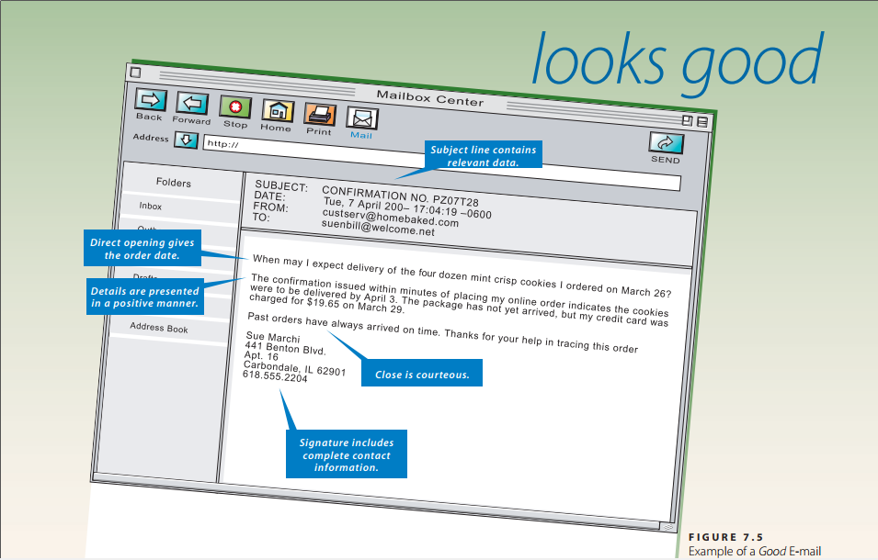

Message Type: Request for Information or Action

Dear Mr DuWayne Sussex,

I would like to get your approval for taking Comm 344 Persuasive Speaking at Ramsey College next semester.

According to new announcement, our company will pay expenses for employees taking job-related coursework or pursuing a program of study leading to a degree. As a sales representative, I believe this course from Ramsay College will greatly enhance my work productivity. Course enrollment enrolment requires the employee’s manager. I will provide transcript and expense documentation after the course ends*.* Classes will begin in four weeks.

I am looking forward to your approval soon. Thank you for your time and should you need further information, you can contact me any time.

Yours sincerely,

Hong Mien

## **Ex 4, p193**

*Technology. Refer to Case 3. Because your company’s educational benefit is new, you have several questions about what expenses are covered. Ideally, you would like the company to reimburse you for tuition, fees, books, meals, and—considering the cost of gas and your 80-mile round-trip commute—mileage. Prepare an e-mail to Renee Runk, HR Specialist, asking for more information.*

Message Type: Request for information

Dear Mrs Renee Runk,

I would like to know more about our company’s new education benefit.

Specifically, I am wondering what expenses will be covered in this benefit. Ideally, I would like the company to reimburse me for tuition fees, books. In addition, I am taking a 80-mile round-trip commute every day. Will it be included in the covered expenses?

I am looking forward to hearing from you. Thank you for your time.

Yours sincerely,

Hong Mien

Technology Department

## **Ex 8, p193**

***Technology. Global.*** *Dahui Lian, a Shanghai official with whom you have met on several past visits to China, is planning to come to the United States. Through your visits and subsequent e-mail exchanges, you have been successful in building a relationship with Dahui. Because of that relationship, he has asked for information about gratuity customs (tipping) in the United States. Use print and Internet resources to gather information about tipping in restaurants, airports, hotels, and other situations he might encounter. Write a message summarizing this information and e-mail it to him.*

Message Type: Social Business Message

Dear Lian:

Tipping is expected for many kinds of personal service in United States. Following are general rules of thumbs for tipping when you may need to keep in mind when you go to United States.

If you enjoy a sit-down meal, or drinks at a bar or lounge, expect to tip. If you request anything delivered to you (from a restaurant or room service), expect to tip. If you take a car service, taxi, or ride share, expect to tip.

If you receive assistance with luggage at a hotel or at the airport, expect to tip a few dollars. If you take a formalized tour, expect to tip. If you use any spa, hail, or nail services, expect to tip. If you are staying at a hotel, expect to tip housekeeping.

However, if you are picking up an order, just receive the kindness of a stranger, or take public transportation, do not expect to tip. Similarly, you generally do not tip if you get fast food or you are at a restaurant with self-service.

I hope this information are helpful to you and hope you will have an enjoyable trip in the United States.

Sincerely,

Hong Mien

LA, United States

## **Ex 20, p195**

*Dan Daily, purchasing manager for the ValueMax supermarket chain, has requested a 10 percent discount on the cost of the 25,000-unit shipment of paper grocery bags delivered to his warehouse last week. The samples he sent support his claim that the logo color is faint and both it and the store name are noticeably off center. You agree. Prepare a letter that approves his claim and retains him as a customer.*

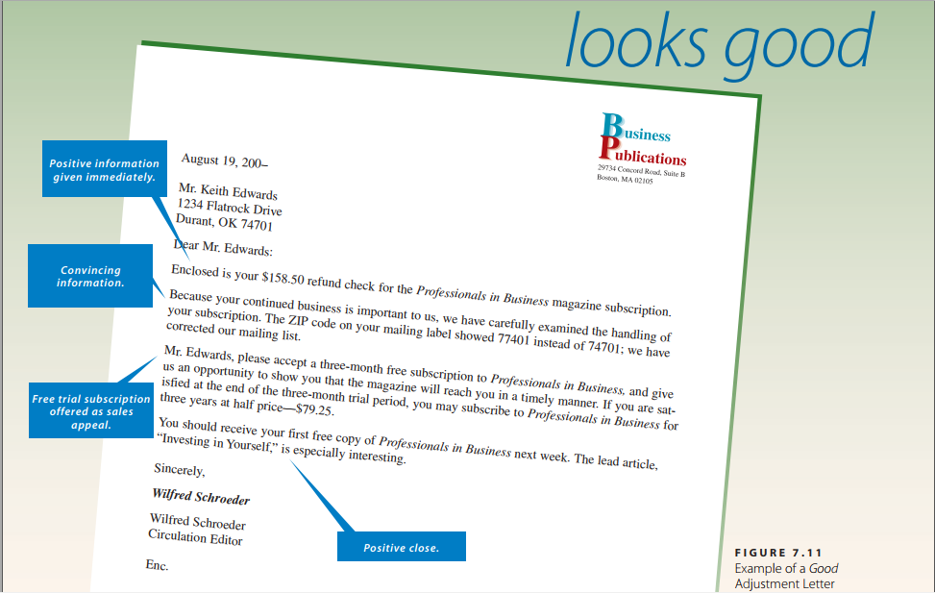

Message Type: Claim adjustment letter

Dear Mr. Daily:

Enclosed is your $150, equivalent to 10% discount of the cost of the 25,000-unit shipment of paper grocery bags delivered to your warehouse last week.

Because your continued business is important to us, we have carefully examined the handling of your package. We found out due to heavy rain there were problems with the logo color and store name during the shipping process.

Mr Daily, please our free shipping for one next order of yours within 10 kilometers. We will do our best to improve your services and hope to maintain long-term relationships with you.

Sincerely,

Hong Mien

Head of ValueMax Marketing Department

## **Ex 30, p195**

*Welcome. You are the president of the Tri-City Industrial Foundation. You have been successful in getting Little Toy Machines, a toy manufacturer, to relocate to your community. This factory will provide employment for 325 people. Write a letter to the president, Roy Stevens, welcoming him and his company.*

Message Type: Social Business Message - Welcome

Dear Roy:  
Welcome to Tri-City, the community of emerging industrial development! We are excited to have you here with us to promote mutual economic development of your company and our city.  
The first few months will be both reaffirming and challenging. As the local residents may not be familiar to your products, it will take time for you to get familiar to the surroundings as well as attract new customers. In addition, the training process for new local employees requires time and efforts as well.

You will not make this journey alone, Roy. You will have us here as friends and consultants to support you with marketing or recruitment, just feel free to contact me anytime. You are part of the Tri-City now . . . come and grow with us!

Sincerely,

Hong Mien

President of the Tri-City Industrial Foundation

# 5 types of business letter

## Request for information or action



Subject: Confirmation No.PZ07T28

Date: Date + Time

From: [abc@homebaked.com](mailto:abc@homebaked.com)

To: suenbill@welcome.net

When may I expect delivery of the four dozen mini crisp cookies I ordered on March 26?

The confirmation issued within minutes of placing my online order indicates the cookies were to be delivered by April 3. The package has not yet arrived, but my credit card was charged for $19.65 on March 29.

Past orders have always arrived on time. Thanks for your help in tracing this order.

Sue Marchi

441 Benton Bivd,

Apt. 16

Carbondate, IL 62901

618.555.2204

## Request approval letter

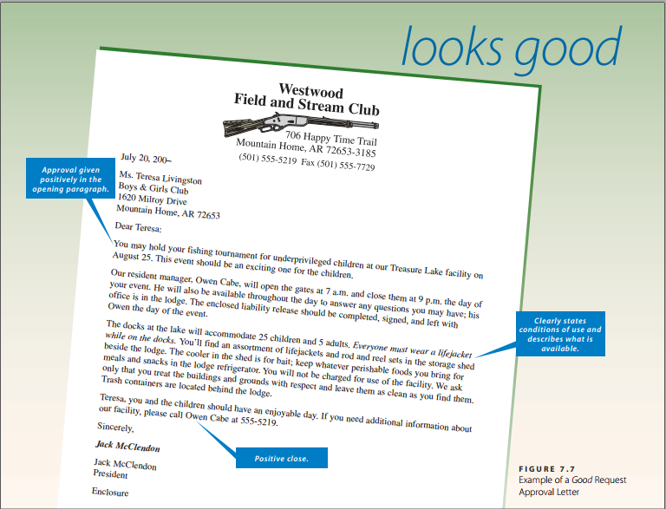

July 20, 200–  
Ms. Teresa Livingston  
Boys & Girls Club  
1620 Milroy Drive  
Mountain Home, AR 72653

Dear Teresa:  
You may hold your fishing tournament for underprivileged children at our Treasure Lake facility on August 25. This event should be an exciting one for the children.  
Our resident manager, Owen Cabe, will open the gates at 7 a.m. and close them at 9 p.m. the day of your event. He will also be available throughout the day to answer any questions you may have; his office is in the lodge. The enclosed liability release should be completed, signed, and left with Owen the day of the event.  
The docks at the lake will accommodate 25 children and 5 adults. *Everyone must wear a lifejacket while on the docks.* You will find an assortment of lifejackets and rod and reel sets in the storage shed beside the lodge. The cooler in the shed is for bait; keep whatever perishable foods you bring for meals and snacks in the lodge refrigerator. You will not be charged for use of the facility. We ask only that you treat the buildings and grounds with respect and leave them as clean as you find them. Trash containers are located behind the lodge.  
Teresa, you and the children should have an enjoyable day. If you need additional information about our facility, please call Owen Cabe at 555-5219.

Sincerely,  
***Jack McClendon***Jack McClendon  
President

Enclosure

## Claim letter

1234 Flatrock Drive  
Durant, OK 74701  
August 2, 200–  
Business Publications  
29734 Concord Road, Suite B  
Boston, MA 02105

SUBSCRIPTION CANCELLATION

The monthly issues of *Professionals in Business* for which I have a three-year subscription have not arrived as they should. I have received only two issues during the past six months.  
On January 15, I returned my three-year subscription renewal, WZ459368A, with a check for $158.50. I received the February and June issues, but the other four issues never arrived.  
Please cancel my subscription and refund $158.50 to me.  
I have enjoyed reading *Professionals in Business* in past years, but the inconsistency in delivery is the reason for cancellation.

*Keith Edwards*KEITH EDWARDS

## Claim adjustment letter



August 19, 200–

Mr. Keith Edwards

1234 Flatrock Drive

Durant, OK 74701

Dear Mr. Edwards:

Enclosed is your $158.50 refund check for the Professionals in Business magazine subscription.

Because your continued business is important to us, we have carefully examined the handling of your subscription. The ZIP code on your mailing label showed 77401 instead of 74701; we have corrected our mailing list.

Mr. Edwards, please accept a three-month free subscription to Professionals in Business, and give us an opportunity to show you that the magazine will reach you in a timely manner. If you are satisfied at the end of the three-month trial period, you may subscribe to Professionals in Business for three years at half price—$79.25.

You should receive your first free copy of Professionals in Business next week. The lead article, “Investing in Yourself,” is especially interesting.

Sincerely,

Wilfred Schroeder

Wilfred Schroeder

Circulation Editor

## Social business message

### Congratulations

### Condolence

### Appreciation

Mr. Sherman Burke  
11463 Grant Lane  
Overland Park, KS 66221-2524

Dear Sherman:  
This year’s ASIP national conference was an overwhelming success . . . and YOU are the one who deserves the credit.  
You selected high-quality speakers who addressed topics that are timely and of interest to our members.  
Adding pre-conference workshops drew even more people to the event and contributed to this year’s record-breaking attendance. By allowing 30 minutes between sessions, you enabled members to enjoy refreshments while networking with speakers or other attendees.  
Our local chapter has always recognized and valued your energy, ability to organize, and sensitivity to others’ needs. You have our respect, admiration, and gratitude for serving as program chair for the conference.

Sincerely,  
Jayne Carroll  
Jayne Carroll  
President

### Invitation

### Holiday greeting

### Welcome

*Falcon, Inc.* Welcome Letter  
**8391 S. Hwy. 89, Jackson, WY 83001-8807  
phone: (307) 555-1964**May 17, 200–  
Mr. Josh Abernathy  
P.O. Box 239  
Wilson, WY 83014-0239

Dear Josh:  
Welcome to the Falcon, Inc. summer internship program! We’re excited to have you work with us in the Shareholder Services Department.  
The next three months will be both reaffirming and challenging. Your educational background in finance and your strong interpersonal skills will provide the foundation for your success. Along the way, you’ll be asked to step beyond your comfort zone as you solve problems and meet deadlines.  
You won’t make this journey alone, Josh. I and others will be here to guide you. You’re part of the Falcon family now . . . come soar with us!

Sincerely,  
***Hank***Hank V. Bock  
Manager